Project ReportRecipe Box Exprezz

short line

Mohana Sreenath K  
23rd October, 2023

# Table of contents

**Introduction**

* + Purpose of the Project
  + Project Scope
* **Project Description**
  + Functionality and Features
  + Technology Stack
  + User Interface
  + How to Use
* **Development Process**
  + Software Development Tools
  + Coding Approach
  + Testing and Debugging
* **Illustrations**
  + Visual Elements
  + Enhancing User Experience
* **Challenges**
  + Overcoming Technical Hurdles
  + User Feedback and Adaptation
* **Conclusion**
  + Project Impact
  + Future Enhancements

# Introduction

### Purpose of the Project

The purpose of the "Recipe Box Express" project is to create a user-friendly web application module that encourages spontaneous meal planning. By rolling a virtual dice, users receive random dish recommendations, complete with names and ingredients. This innovative approach aims to make the meal selection process more enjoyable and adventurous. 

### Project Scope

The project scope covers the development of the Recipe Box Express module. It leverages web development technologies such as HTML, CSS, and JavaScript to provide an engaging and playful user experience.

# Project Description

### Functionality and Features

* Dice Rolling: Users can roll a virtual dice to receive a random dish recommendation.
* Dish Details: The selected dish's name and ingredients are displayed.
* User Interaction: The interface is designed for simplicity and ease of use.

### Technology Stack

* Integrated Development Environment (IDE): Visual Studio Code
* Web Development Technologies: HTML, CSS, JavaScript

### User Interface

Recipe Box Express boasts a visually appealing and user-friendly interface. It employs a combination of bright colors and small, charming illustrations to engage users. The "Roll the Dice" button is prominently displayed, encouraging user interaction.

### How to Use

* Visit the Recipe Box Express web application.
* Click the "Roll the Dice" button to generate a random dish.
* The selected dish's name and ingredients will be presented for your culinary inspiration.

# Development Process

### Software Development Tools

* Visual Studio Code: The IDE used for coding and project management.

### Coding Approach

* HTML, CSS, and JavaScript were used to build the web application.
* The random dish selection is based on JavaScript logic.

### Testing and Debugging

* Extensive testing was performed to ensure the module's reliability.
* Debugging addressed any issues encountered during development.

# Illustrations

### Visual Elements

Small and delightful illustrations have been incorporated to enhance user engagement. These visual cues add an element of fun to the meal selection process.

### Enhancing User Experience

The project focuses on providing a playful and enjoyable user experience through an appealing design and small illustrations.

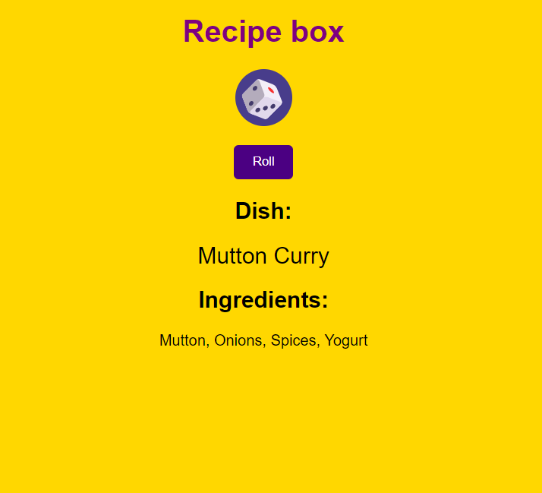

# Challenges

### Overcoming Technical Hurdles

The project faced technical challenges related to JavaScript logic and user interface design. These challenges were overcome through research and problem-solving.

### User Feedback and Adaptation

User feedback was collected and analyzed to refine the user interface and functionality. This iterative process allowed for continuous improvement.

# Conclusion

### Project Impact

Recipe Box Express adds an element of spontaneity to meal planning. It appeals to a wide range of users, from amateur cooks to seasoned chefs. The playful dice-rolling feature provides a unique way to discover and prepare dishes, making the project a valuable addition to the world of culinary exploration.

### Future Enhancements

Future enhancements may include expanding the dish database, user profiles, and sharing features. These developments aim to provide even more engaging and enjoyable culinary experiences for users.

#### By

Mohana Sreenath Kodidela

Date: 23rd October 2023

RA2111031010021

CSE-IT R2

Web Programming 18CSE361T

#### Under :

Dr M . Anand sir

[GitHub Repository](https://github.com/MohanaSreenath/Web_Programming/tree/main/Game_recipebox)